Wednesday 10 April 2019

Official visit of H.E. Mr Edi Rama, Prime Minister of the Republic of Albania

As part of the official visit of the Prime Minister of the Republic of Albania, a dinner was organised yesterday at the Residence of the Ministry of State, to which H.E. Mr Edi Rama, his accompanying delegation, Monegasque personalities and representatives from the private sector were invited.

H.E. Mr Edi Rama was received today by H.S.H. the Sovereign Prince. He also took part in a meeting held by the Monaco Economic Board at the Yacht Club de Monaco, during which the Albanian Ambassador discussed a project to develop a luxury marina on the Adriatic Coast.

The visit, part of economic and environmental cooperation between the two countries, concludes today.

For more information, see the attached Technical Information sheet / https://www.facebook.com/palaismonaco

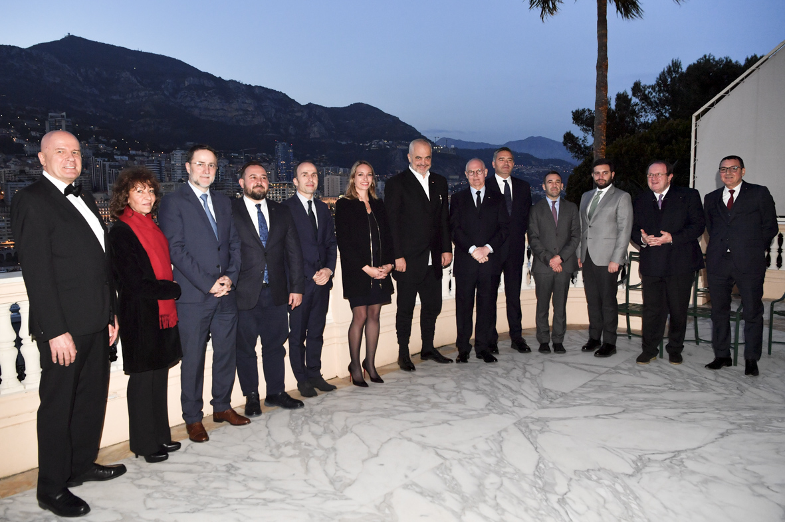
© Government Communication Department / Manuel Vitali

